Suggested Bidding 1
N | E Dealer | S | W
 | Pass | 1S | Pass
1NT | Pass | 3NT | Pass
Pass | Pass
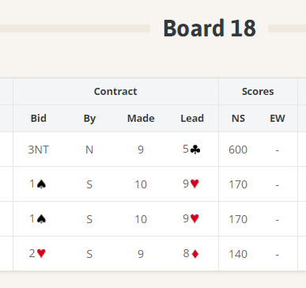
Thursday Bidding Tips Board 18 played on 19/4/2018 Junior Champs
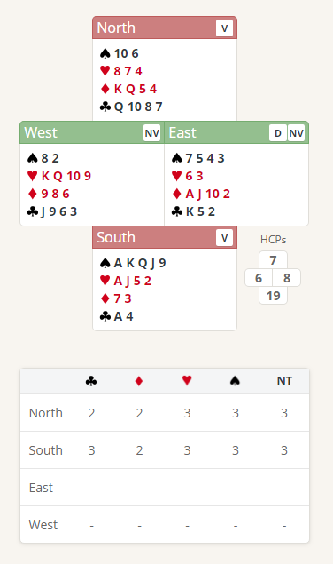

Suggested Bidding 2
N | E Dealer | S | W
 | Pass | 1S | Pass
1NT | Pass | 3H | Pass
3S / (3NT) | Pass | 4S/(Pass) | All Pass

- Souths bid of one Spade shows 12-19 points and at least 4 Spades.
- Norths reply of 1 No Trump shows 6-9 points and makes no promise about any shape or suit. (Cannot bid a new suit at the 2 level as this requires 10 points)
- South with 19 points now knows that there is at least 25 points, so game is on. South has a range of bids but must jump to show the points
  - 3 Hearts shows 4 hearts and 5 spades and 16 Plus points
  - 3 No Trumps shows 19 but could be risky with the 2 doubleton minor suits
- If South bids 3 Hearts The change of suit means north should bid again
  - North could bid 3 No Trumps with the minor suits covered
  - Or 3 Spades showing a preference for spades over hearts with a 5/2 fit
- If North Bids 3 Spades South should Bid 4 Spades (thinking that North possibly has 3 spades and showing game points)
- If North Bids 3 No Trump South Passes as North is showing the unbid minors
If North is playing in 3 No Trumps
East has a choice of 2 leads 2 Diamonds (can lead away from an Ace in No trumps) or 5 Clubs (Middle of 3 ) both leads need to won in Norths Hand
If south is playing in 4 Spades
West should lead KH (promises Queen) or 3C
- If K Hearts is lead play low Heart from both North and South
- If 3 Club Play low from North and take the king with the Ace

